





**CERTIFICATE**

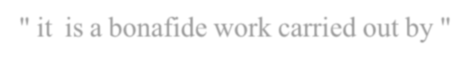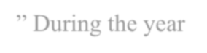

This is certify the project report entitled study on "**ROLE OF COMMERCIAL BANKS IN FINANCING SME’S**" it is a bonafide work carried out by "**MOHD OMER**" **H.T NO. 1174- 21-408-010** in partial fulfilment for the award of the degree of “**MASTER OF COMMERCE**” department of M.com **S.D SIGODIA COLLEGE OF ARTS & COMMERCE & P.G CENTRE** charkaman, Charminar, Hyderabad & approved by “**OSMANIA UNVERSITY**” During the year **2021-2023**.



This project not has been submitted to any other university or institution for the award of Any degree/ certificate

Mrs. NEHA AGARWAL Mrs. NEHA AGARWAL Dr. CH DAL PADAL



**PROJECT GUIDE**

**(H.O.D)**

**PRINICIPAL**

EXTERNAL EXAMINER



**CERTIFICATE**

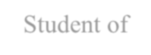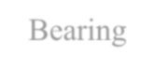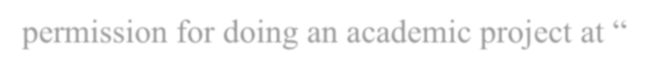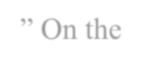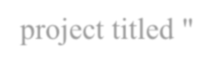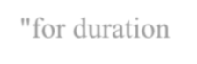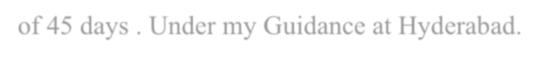

This is to certify that **MOHD OMER** Student of **S.D SIGNODIA COLLEGE OF ARTS & COMMERCE & PG CENTRE** Bearing **Roll No: 1174-21-408-010** Has given permission for doing an academic project at “**INNOVATIVE TECHNOLOGIES**” On the

project titled "**ROLE OF COMMERCIAL BANKS IN FINANCING SME’S**"for duration

of 45 days . Under my Guidance at Hyderabad.



This project report is purely for the purpose of curriculum award of degree.



We wish you all the best for future endeavours



**(General Manager)**



**ACKNOWLEDGEMENT**



I wish to express my deep since of gratitude to all the people behind the screen have played an

important role in completion of the project.



I would like to thank my project guide **Mrs. NEHA AGARWAL** for providing good Guidance during period session and motivating us all the time.



My sincere thanks to **Mrs. NEHA AGARWAL (H.O.D), M.COM Dept of S.D SIGNODIA COLLEGE OF ARTS & COMMERCE & PG CENTRE** for the kind Encouragement and constant support and giving the valuable suggestions to Complete my project.



I Thank to my Principal **Dr. CH. DAL PADAL** for providing us good learning ambience And necessary support in accomplishing this project work.

MOHD OMER 1174-21-408-010



**DECLARATION**

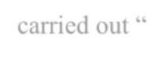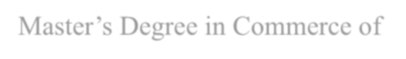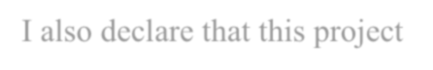

I **MOHD OMER** the undersigned, hereby declare that the project report entitled “**ROLE OF COMMERCIAL BANKS IN FINANCING SME’S”** carried out “**INNOVATIVE**

**TECHNLOGIES**”is my original work written and submitted by me in partial fulfilment of Master’s Degree in Commerce of **OSMANIA UNIVERSITY.** I also declare that this project has not been submitted earlier in any other university or institution.



Place: Hyderabad



**MOHD OMER**



Date:



**1174-21-408-010**





**CONTENT INDEX**

|  |  |  |
| --- | --- | --- |
| **CHAPTER. NO:** | **TITLE** | **Page. No:** |
| **I.** | INTRODUCTION | 3-17 |
| **II.** | RESEARCH METHODOLOGY | 18-20 |
| **III.** | DATA ANALYSIS & INTERPRETATION | 21-30 |
| **IV.** | FINDINGS OF THE RESEARCH | 31 |
| **V.** | SUGGESTIONS | 32-33 |
| **VI.** | LIMITATIONS | 34 |
| **VII.** | CONCLUSION | 35 |
| **VIII.** | BIBLIOGRAPHY | 36 |